Lines of Symmetry
Kid Pix Drawing Program

Objective:
The student will identify lines of symmetry in stickers and in objects drawn with the kaleidoscope tool.

Technology Skills: (1E, 7A, 10B)
- Choose a printer
- Demonstrate the ability to use a drawing program
- Insert graphics

TEKS:
The student recognizes congruence and symmetry and is expected to:
- 3.9 (B) create two-dimensional figures with lines of symmetry using concrete models and technology; and
- 3.9 (C) lines of symmetry in two-dimensional geometric figures.
Duration of Lesson: 1 lesson using computers

Before the Computer: Teacher will instruct the class on how to determine lines of symmetry.

Procedure:

- Direct students to click on Required Technology Lessons link on Student Technology Resources. Then, direct them to the appropriate symmetry graphics file.
- Right-click on the symmetry graphic link and go to “Save Target As”.
- Save the graphic in Home Directory (H:drive).
- Open Kid Pix
- Go to Add in the menu bar to Add Graphic.
- Change File of type to JPEG (jpg).
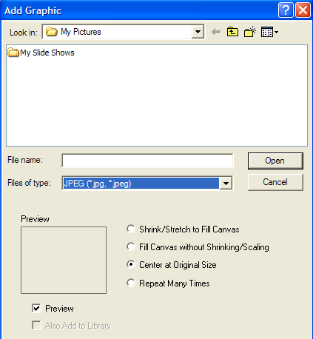
- Navigate to your H:drive and select the symmetry graphic saved in steps 2-3.
- Expand the graphic to fill the page, if needed.
- Use the Text tool to type your name in the designated area.
- Name (symmetry_initials) and save document to Home Directory (H: drive)
- Use the Line tool to draw the lines of symmetry on a given object.
- Select 3 stamps from the Stamp tools which have at least one line of symmetry and stamp each inside the designated space.
- Use the line tool to draw all of the lines of symmetry on each stamp.
- Use the Kaleidescope tool to draw 3 figures and then draw all of the lines of symmetry on each one using the Line tool.
- Use the Undo Guy or Pencil Eraser to erase mistakes, as needed. Be careful!
- Save often as you work. Make sure it always saves in the H:drive. Students will answer YES to replace the file when prompted.
- When finished save a final time and then direct students to print the file.
- Go to File to Print. Leave the Full Page selection on.
- Click the Options button on the Print This Picture window.
- Choose the color printer, if available, and # of copies desired. The default is normally on 1 copy.
- Click OK to return to the Print This Picture window.
- Click OK to print the file.
- Exit Kid Pix

Assessment: Revise rubric as desired.
Math Skills | Correct lines of symmetry | 20 pts
Tech Skills | Used line tool to draw lines of symmetry. | 20 pts
 | Inserted 3 stamps inside box. | 20 pts
 | Used the kaleidescope tool to draw 3 images. | 20 pts
 | Chose the correct printer. | 20 pts

