Characteristics of Matter
MS Word

Objective:
The student will use technology skills to classify images based on their characteristics and properties of matter.

Technology Skills: (7A, 7B, 7C, 10A, 10B)
- Demonstrate the ability to resize graphics
- Demonstrate the ability to apply cut, copy, paste and move functions in an electronic document
- Demonstrate the ability add and manipulate text boxes
- Demonstrate the ability to rotate, duplicate, group and align graphic objects

TEKS:
- 3.7 (B) Identify matter as liquid, solids, and gases.

Duration of Lesson: approximately 1-2 lessons

Before the Computer: Teacher will instruct the class on the characteristics and properties of matter.

Procedure:

Day One
- Direct students to click on Required Technology Lessons link on Student Technology Resources. Then, direct them to appropriate lesson.
- Open Characteristics of Matter.
- Click behind Name and type your name. Then, click behind Date to type date.
- Save document in your Home Directory (H: drive).
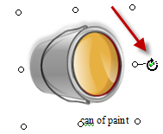
Steps:
- To begin, find the images that need to be rotated.
- Click once on the image to select it.
- Move your mouse to the green handle.
- The mouse will curve around the handle.
- Hold the mouse button down and rotate the image.
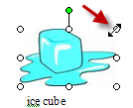
- Find the images that need to be resized.
- Click once on the image to select it.
- Move you mouse to a corner handle.
- Move towards the image to make it smaller.

- Copy the images. This will give you a working copy of the image. If an image is accidentally deleted, the student can make another copy.
- Right-click on the image.
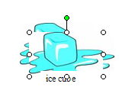
- Click copy on the pop-up window that appears.
- Use the Ctrl + V on the keyboard to paste the image.
- The image will appear on top of the original image.

- Now, move the images to the part of the Venn Diagram that describes its characteristics.
- Click on the copied image
- Hold the mouse button down as you move the image down the page.
- Let go of the image when you reach the desired part of the Venn Diagram

- If the Venn Diagram moved, click on the diagram and drag it back to the top of the second page.
- If an image cannot be seen and is behind the Venn Diagram, you should:
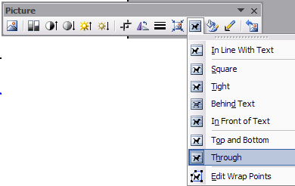
- Press Ctrl+Z to undo the move (or Edit/Undo)
- Click on the image to select it.
- On the picture tool bar, click on the picture of the dog (text wrapping) and select Through.
  - If you do not see the picture toolbar, click View/Toolbar/Picture.

- Now move the image to the Venn Diagram. The image should be on top of the Venn Diagram instead of behind it.

Assessment: Revise rubric as desired
Science Skills | Correct Content:
 | Identified the correct characteristics of matter. | 50 pts
Tech Skills | Rotated graphics correctly | 10 pts
 | Resized graphics correctly | 10 pts
 | Copied and pasted graphs correctly | 10 pts
 | Moved graphics correctly | 10 pts.
 | Used Picture Toolbar as needed | 10 pts
 | Total

