3 Circle Venn Diagram: State of Matter

Name______________________________________Date___________________________Subject _________________________

You will use technology skills to classify the images below based on their characteristics and properties.


Drag the image to the correct part of the Venn Diagram. Rotate the images as needed, and resize the images to fit in the correct space on the Venn Diagram

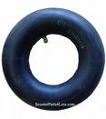




water vapor
can of paint
ice cube

inner tube

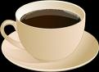
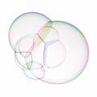
ice cube


Kitten

soap bubble
tear drop
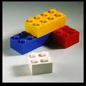
Ketchup

cup of coffee
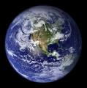
Leggos
Earth
Air

Earth
1. Solid
2. Liquid
3. Gas
6. Solid & Gas
5. Liquid & Gas
4. Solid & Liquid
7. Solid, Liquid & Gas

