Author Bookmarks

Technology Project Description:
Students will design their own bookmark using Microsoft PowerPoint. They will gather information from the Internet about a favorite author or person. The information will be presented to the class in the form of four bookmarks.

Project Directions:
Creating the First Bookmark:
- Open Microsoft PowerPoint and select a blank slide.
- If the rulers are not showing, pull down the View menu to Ruler
- Use the line tool and divide the slide into four equal parts. Each part will become a bookmark.
- In the first bookmark space, use a text box to add the author’s name.
- Use another text box to add interesting information about the author.
- Change the fonts and sizes to make the bookmark look nice.
- Add an image of the author, if possible, or an appropriate graphic.
Duplicating the bookmark:
- Hold the shift key on your keyboard.
- Click the image and then click each text box. (Be sure to continue to hold the shift key down. This will allow you to select more than one object.)
- Let go of the shift key.
- Go to Edit menu to Copy.
- Go to Edit menu to Paste.
- Click the center of the image and get the 4-sided arrow and drag the image to the next bookmark location. Repeat in the last 2 boxes.
- Print and cut apart the 4 bookmarks.
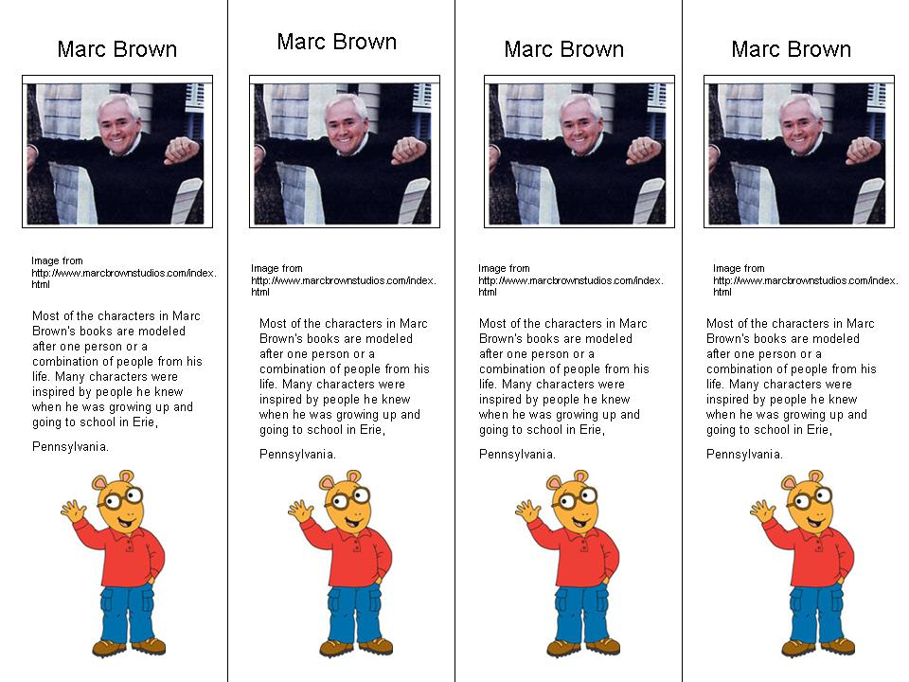
Idea presented at T.C.E.A. in Austin 2005 by Tammy Worcester. See more of Tammy’s projects at http://essdack.org/tips

