How to Create Mini-Books

Technology Project Description:
Students will create their own mini-book to retell a story they have read or their own original story. This works well with Big Books read or created in class in the primary grades. Other ideas: biography of an inventor, a famous event in history, math facts, abc books, or information learned in class during a curriculum unit. This is the publishing phase of their writing.

Activity:
Each student will create a 5 or 6 slide show in PowerPoint to illustrate their story. This can be with clipart or their original artwork that has been scanned into the slideshow.

How to Print Mini-Book
- After the project has been completed and saved, then choose the File Menu, then choose Print.
- Under Print What Section, choose Handouts from the drop down menu box.
- Choose either 4 or 6 slides to a page and the page orientation must be horizontal. Color: Pure Black and White

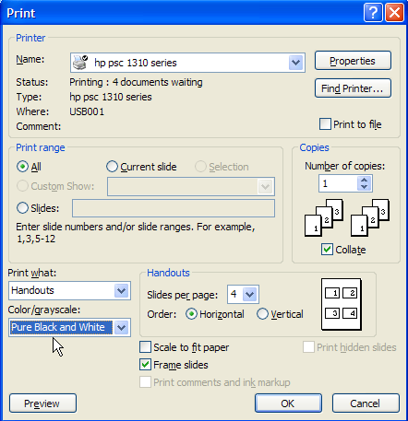
- Fold printed page vertically with backside to backside with pictures on outside.

- Cut between each row at pictures. (Do not cut on the fold.)

- Staple Mini-books.

