Bingo Card with Free Space

Technology Project Description:
Students will use the template to create their own Bingo Card. They will use the words or numbers provided by the teacher. Example: color words, vocabulary words, spelling words, numbers, math facts, or number words.

Activity: Each student will create their own Bingo Card. Each card will have 3 columns and 3 rows with a free space. The Teacher will give the list of items to choose from for each box.

Template File Name: freespace_bingo_template

Example
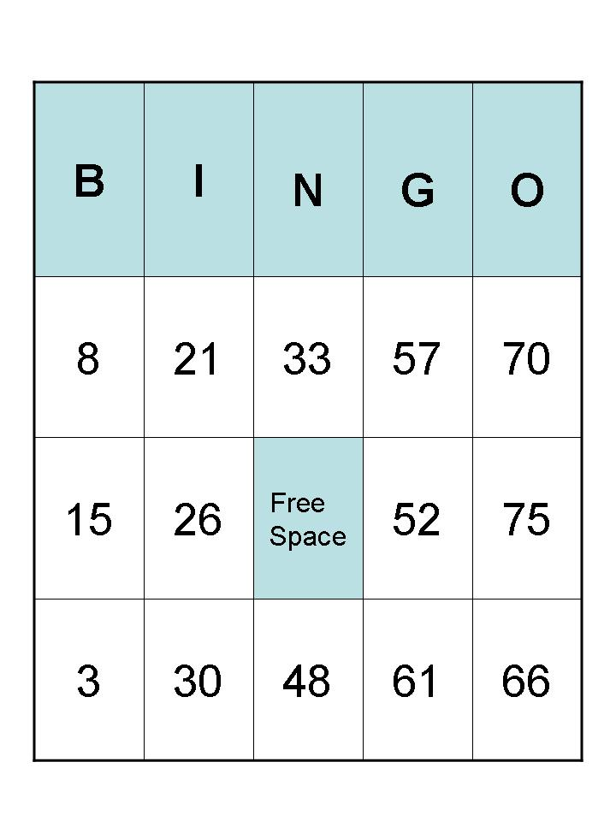
Student Directions:
- Open the teacher created template. Save it in your home directory.
- Click to enter the information required by your teacher in each box on the Bingo Card.
- Change font style, size, and color, if desired.
- Save Bingo Card to your home directory.
- Print Bingo Card to play the game. It may be teacher or student directed.

