II. Creating a Class List Using Excel
Template File Name: excel_1(Sheet 2)
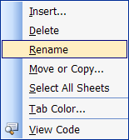
Preparing the Sheet
- Right-click on sheet 2 tab at the bottom of the screen. Click Rename
- Type Class List. Press Enter
- Right-click on the word Class List; click Tab Color. Choose a color and click OK.
- On the Menu bar, click Insert / Worksheet. This will add a new worksheet for later use.
- Drag the worksheet after the Class List tab.
- Click View / Page Break Preview then View / Normal. This will get the page break dotted lines to appear.
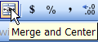
Row Height
Place the cursor on the line between rows 1 and 2 until you get a cross bar. Double-click to custom fit row height.
Tip:
Merging Cells
- Highlight Cells A1 – I1
- On the formatting bar, click the Merge and Center icon
- Change formatting of the title to size 16, font Ariel and bold.
- Correct Row height of title.

Editing Text
- Select A3 – H 5. Change the formatting to bold, size 12, and font Ariel

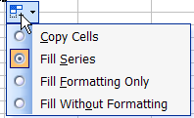
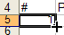
Fill Down Text
- Select Cell A5.
- Place you cursor on the bottom right corner of the cell.
- Drag the single line cross down to cell A30
- Click the Smart tab icon to select Fill Series.

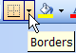
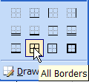
Borders
- Highlight cells A5 – D30.
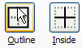
- Click the Border tab. Click the All Borders Preset button.
- Highlight Cells B4. Click the All Borders Preset button.
- Select cell H4. Click the Right Border Preset button.
- Highlight C3 – H3. Right-click / Format Cells / Borders tab. Click the Outline button/ Inside button.
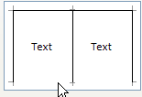
- Click the bottom border line to toggle it off. Do not click OK.

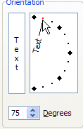
Angled Alignment
- Select the Alignment tab.
- Click Wrap Text box under Text Control.
- Click the red diamond and drag to up to 75 degrees. Click OK.

Column Width / Row Height
- Double click lines starting between C – I to custom fit the columns.
- Click and drag the line between B and C to widen the B column to 252 pixels.
- Highlight rows 5 – 30.
- Click and drag the line between 5 and 6 to 26 pixels.

Options:
Add clip art.
Color cells and text.
Change checklist text. Italicize text.

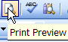
Previewing and Printing
- On the standard Menu Bar Click Print Preview icon
- If you do not see the margins, click the Margins button.
- Move the margins by placing your cursor on one of the vertical black lines until you get a 4-headed arrow. Move the line until you get your information centered.
- If there is a next button, then you have extra pages.
If you do not see the Standard menu bar, click View/ Toolbars / Standard.

Any toolbar that is missing can be viewed this way.
Tip:

