I. Creating a Schedule Using Excel
Template File Name: excel_1(Sheet 1)
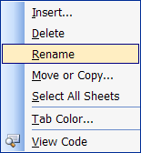
Preparing the Sheet
- Right-click on sheet 1 tab at the bottom of the screen. Click Rename
- Type Schedule. Press Enter
- Right-click on the word Schedule; click Tab Color. Choose a color and click OK.
- Click File/ Page Setup. Change Orientation to Landscape
- Click the Margins tab. Choose .5 for each margin
- Click View / Page Break Preview then View / Normal. This will get the page break dotted lines to appear.

Merging Cells
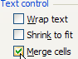
- Highlight Cells A1 – F1
- On the menu bar, click Format Cells/ Alignment tab or right click on the highlighted cells and click Format Cells/Aignment tab.
- Click the Merge Cells box under Text Control
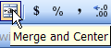
- Use the Merge and Center icon on the formatting bar for a simpler way to merge the cells for lunch and duty.
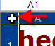
- You can type the text for Lunch and Duty in the cells after merging.
Column Width/ Row Height
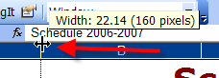
- Click the square in the upper left corner of the spreadsheet to select all cells. It is to the left of A and above the 1.
- Click and drag the line between A and B until you get around 22.14 or 160 pixels. This will stretch the columns to the page break.
- Click in any cell to deselect all the cells
- Column A does not need to be that wide. Double-click on the line between A and B to custom fit the text.
- Select Rows 4 through your last number. Click and drag the line between rows 4 and 5. Make the height around 31 pixels.

Inserting / Deleting Rows
- Highlight Row 2 by moving your mouse over the number 2 until you get a black arrow and click.
- On the menu bar, click Insert / Row. A row appears above the row you highlight. Add another row. This gives space between the schedule and title.
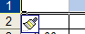
- Insert other rows if you need to add times to the schedule.
- If you want to remove a row, highlight the row and click Edit/Delete.
- Notice the numbering of the row changes as you insert rows. You do not have to use the format painter to remove formatting.

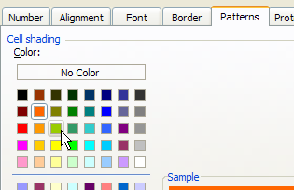
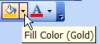
Formatting Cells
- Highlight the cells B3 – F3
- Right-click on the cells. Click Format Cells or click the paint can on the Formatting tool bar.
- Click the Patterns tab. Select color.
- Highlight the cells A4 – A11. Change the color of those cells.
Editing Text (Text will not appear correctly until the column width is corrected)
- In cell B3, type Monday. Place you cursor on the bottom right corner of the cell.
- Drag the single line cross to cell F3. The days of the week will fill in automatically.
- Highlight these cells and click the Center alignment button. Use the Font color button to change color.
- If you inserted extra rows, click in the cells under column A to add extra times.
- Select A1. Change the formatting of the title to bold, size 26, font Verdana, any color, and center alignment.
- Highlight all the cells from A3 to F11. Change font to Verdana and size 18.
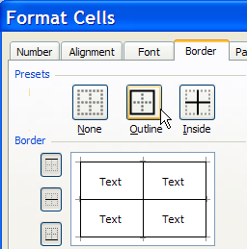
Borders
- Highlight cells F3 - F 11. Right-click in the shaded area. Click Format Cells.
- Click the Border button on the Formatting Menu.
- Click the Outline and Inside Preset buttons.

Previewing and Printing
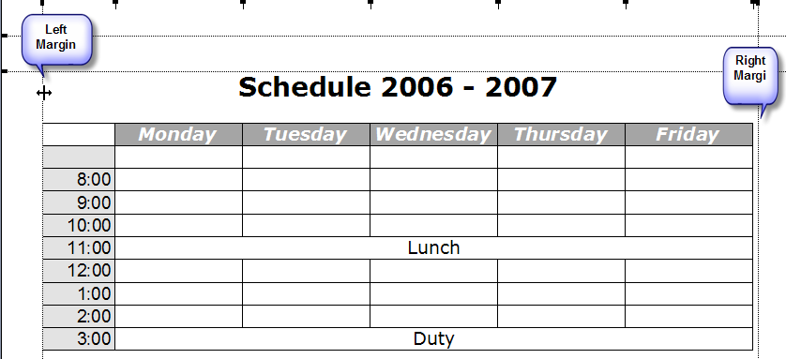
- Click File / Print Preview
- If you do not see the margins, click the Margins button.
- Move the margins by placing your cursor on one of the black lines until you get a 4-headed arrow. Move the line until you get your information centered.
- If there is a next button, then you have extra pages.
- Click Print.
Use File/Print Area if you have certain information to print instead of the whole worksheet.
If you find you have more sheets than expected, you may have accidentally typed somewhere on your sheet. Print Preview’s Next button will sow on which page it is located.
Tip:

