Using Excel to Make a Pictograph

1. Enter data and highlight to make a chart. Click on the Chart Wizard tool at the top of the screen.

2. Select a column or bar graph, clicking Next as prompted, typing in a Chart Title, labeling the x and y axes.

3. Click OK to save the graph as an object in Excel.

4. Click once on the bars to select all of the bars, then click again on the edge of one of the bars to select just one.

- From the Draw menu (View/Toolbars/Drawing), click on the ClipArt icon 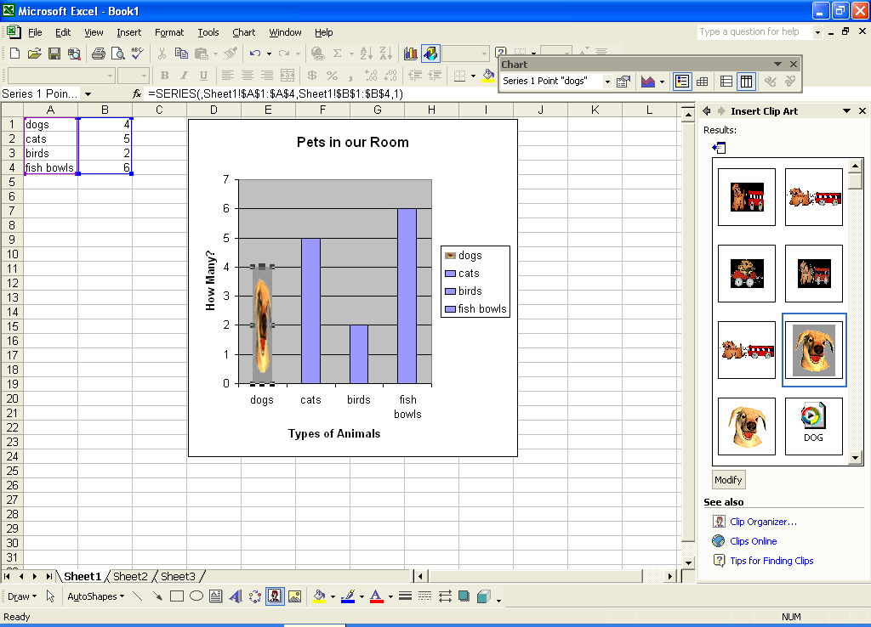 or go up to Insert/Picture/ClipArt.

- Type in a keyword for the type of picture you want (i.e., bird, cat, etc.). Click Enter.

- Double-click on the picture you want to insert.

- Now, your picture may come in stretched at first. Don’t panic.

- To fix this, right click on the “picture bar” now (your stretched picture).

- Select Format Data Point.

- In the Format Data Point window, click on Fill Effects.

- Under Format, select Stack and Scale to: 1 units/picture. Click OK. OK.

- If your chart seems too small, click anywhere on it to see the graphic handles in each corner. Click and drag on a corner to resize the chart.

- Click on another bar and follow the same steps, selecting a different picture.

