Teacher Directions
Creating a Timeline of your Life

Prior to the lesson:
- Save the “Timeline Example.xls” file to your computer. The first sheet in this spreadsheet is the template for students to use. The second sheet gives an example of the expected student product. This sheet can been deleted by right clicking on the tab at the bottom and choosing “delete sheet”. Once the example has been deleted save this changed copy into the student shared folder.

Completing the lesson with students:
- Students will choose at least 5 events from their lives for their timeline. At least one of the events should be from the past, one from the present, and one should be in the future. Have students write them on their student instruction sheet (below). You may want to teach them to subtract their siblings age or number of years parents have been married to determine the year these things happened. Also, the date must be entered “month day, YYYY” so they may need to estimate months, days, and year for some events. In the example I wrote the events in sentences, but they can be done with simple statements, or single words.

- Students will open the “Timeline Example.xls” template from the student shared folder. They should then save the file to their own folder. Once they have saved their own copy they can enter the events and dates into the spreadsheet. They date can be entered “MM/DD/YYYY” but it will automatically be converted to “Month Day, YYYY”.

- Next students will sort their information according to date. To do this they need to highlight all the data they have entered including the column titles. Next they should click data and then sort. They will get a small window asking what to sort by. They can use the drop down menu to choose “date”.

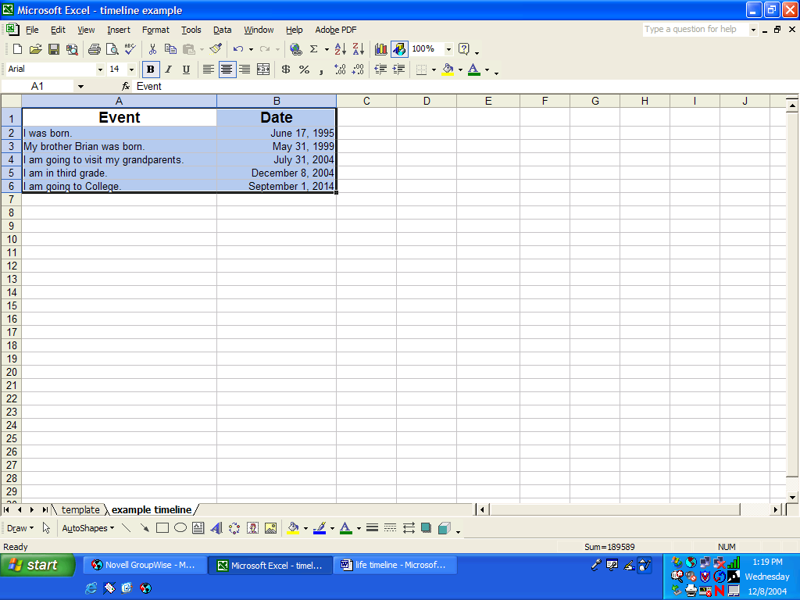
- Next they can create their timeline by using the chart wizard. Again they must highlight the cells where they have entered data including the titles. No blank cells should be highlighted. To begin, click the chart wizard icon:

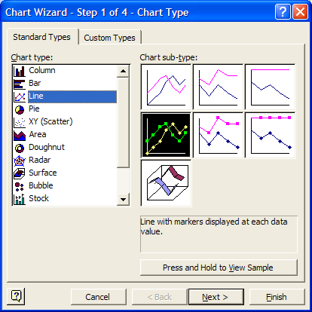
- On the first wizard screen, students need to choose line graph, then click next.

- The next box will be the data range box. Students can just click next.

- On the next screen, students can enter the appropriate title of their choice or you can tell them what to title this graph.

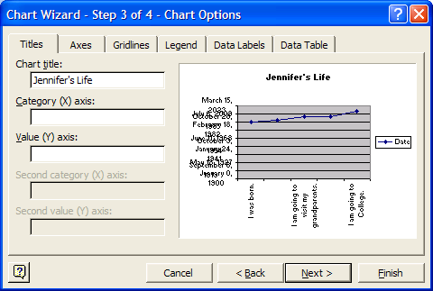

- Students will then click on the “Axes” tab.

- On this screen, students will uncheck ALL boxes.
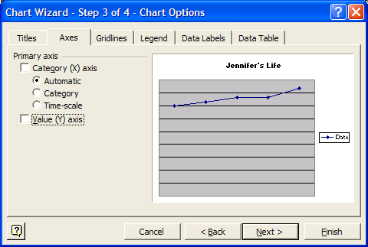

- Students will then click on the “Gridlines” tab.

- Students then need to uncheck ALL boxes in this menu.

- Students then need to click on the “Legend” tab and uncheck all boxes.

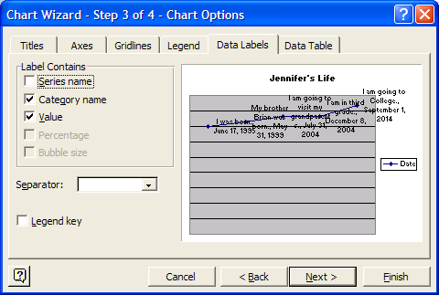
- Students then need to choose the “Data Labels” tab and check the boxes next to Category Name and Value.

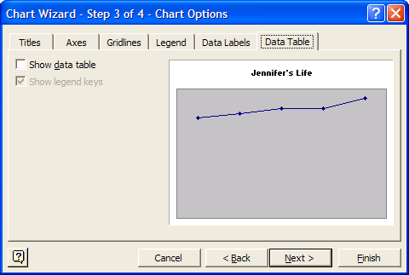
- Students can then click the button.

- Students need to select “As an object in…” and then choose “Finish”.

- The timeline can then be resized by grabbing the little black squares, called handles, on the edges of the graph. Any part of the timeline can be moved around by left clicking one time on it and then dragging or resizing. Colors and text style can be changed by right clicking and choosing “Format Data Labels” or “Format Data Series” or whatever format you are trying to change.

- Students can add in clip art, scanned pictures, or take digital pictures and add them to the timeline also.

- Last, students can add three sentences describing time relationships (ex: I will graduate in one decade. My brother is four years younger than I am.) in one of several ways. (A) They can print the graph, cut it out and glue it to writing paper to write the sentences. (B) They can copy the graph by selecting the entire thing, right clicking, choosing copy, then open a Word document and choose Edit, then Paste. They can then type their sentences on the Word document. (C) Finally they can type their sentences in to the spreadsheet below the graph.

Student Data Gathering Chart
Creating a Timeline of your Life

Events | Date

