Famous American Business Cards

Description: Students will use the Internet to gather information about 6-8 Famous Americans. The information will be presented to the class in the form of business cards.

Activity: Each student will create business cards for 6-8 famous people. Each card will give information about the individual which will let the person who receives it know something about the person. It should include a line that indicates why the individual is famous.

Internet Sites:
Kids Click - Biographies This site gives an annotated list of sites to find biographical information. (http://sunsite.berkeley.edu/KidsClick!/)
Meet Amazing Americans Discover the inventors, politicians, performers, activists and other everyday people who made this country what it is today. (http://www.americaslibrary.gov/cgi-bin/page.cgi/aa)

Template File Name: BusinessCardTemp

Sample Card: 1st: Type the text
Leonard Bernstein

1st American Born Orchestra Conductor

August 25, 1918 - October 14, 1990

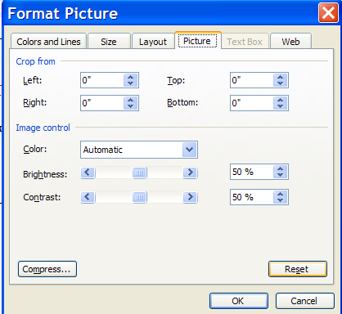

Directions for adding a watermark picture:
2nd: Insert a picture to the document from clipart or a file
3rd: Format the picture
- Size Tab: Height under 2”
- Layout Tab: In front of text
- Picture Tab: Image Control-Color = washout
4th: Center it on top of the business card
5th: At the bottom of the screen (on the left) click the arrow beside Draw.

Drag to “Order” and then to “Send Behind Text”.

