How to Create a Brochure with Microsoft Word
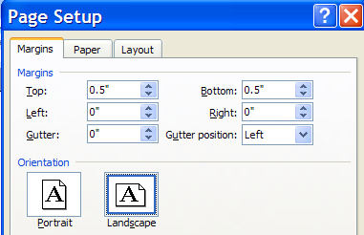
Format the brochure:
- Open a new Word document.
- Go to File to Page Setup.
- Change the page orientation to landscape.
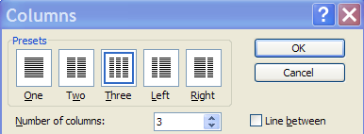
- Change the top and bottom margins to .5 in. and the left and right margins to 0 in.
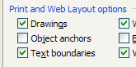
Add columns:
- Go to Format to Columns.
- Set the number of columns to 3.
- Go to Tools to Options. Enter a check for Text Boundaries.
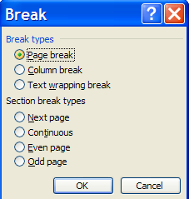
Make a second page:
- Go to Insert to Break and choose Page Break. (This will give you the 2nd page for the brochure. Reminder: Printing will be different for a brochure.)

Set the Page View:
- Go to View to Zoom and select Whole Page.

Add text:
- Select the Text Box from the drawing tools (at the bottom of the screen)
- Drag a textbox for the 1st column of information. Be sure to leave ¼ to ½ inch space around the textbox.
- Type the desired text in the box. Repeat for each column.

Format text:
- Highlight the text you want to format. Change the font, size, style and alignment as desired.

Add Graphics: (Use clipart or picture files previously saved.)
- Go to Insert to Picture and choose either Clipart or From File.
- Select a graphic and click Insert.
- Double-click the graphic and choose the “Tight” layout to move the graphic to the desired place.

Print:
- Go to File to Print Preview. (Check the layout.)
- Move to the 1st page of the brochure.
- Go to File to Print.
- Select the desired printer.
- Click Current Page.
- Click OK.
- Place the paper back in the printer and repeat steps 1-6 for side 2.

