Make a Poster with Microsoft Word

To begin:
- Open a new Word document.
- Go to View to Toolbars. Make sure there is a checkmark by Picture, Drawing, and WordArt.

Design Poster:
- Type the poster title and other text.
- Textboxes can be used to place information in different areas.
- Layouts can vary.

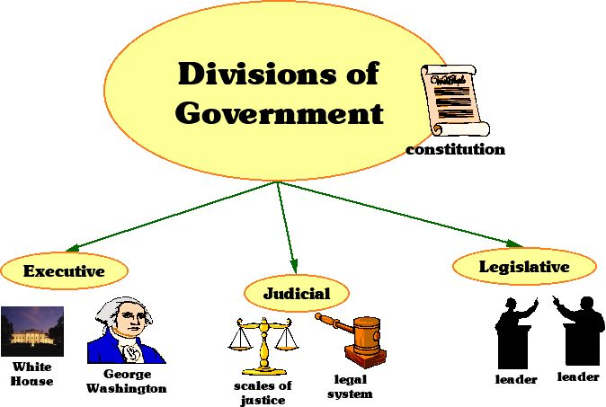
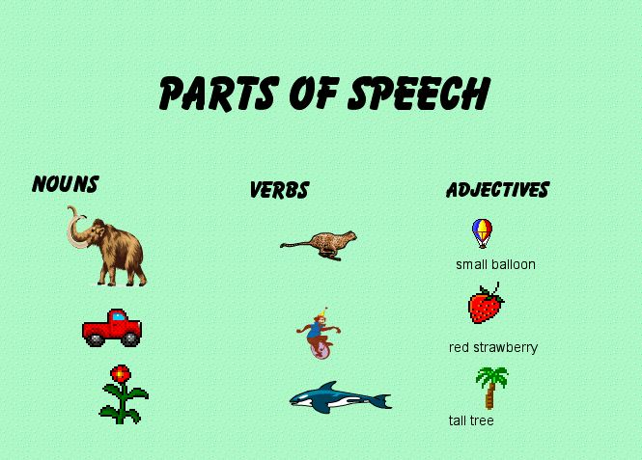
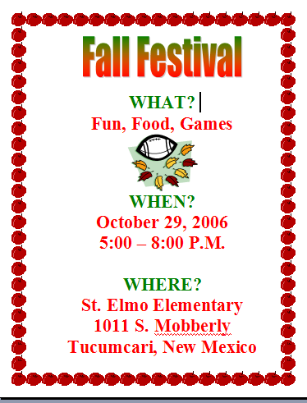
Layout Samples:

Format Text:
- Highlight the text you want to format.
- Go to Format to Font. Choose the desired font, style, size, color, and effects.
- Choose WordArt if you want to have a special title effect.

